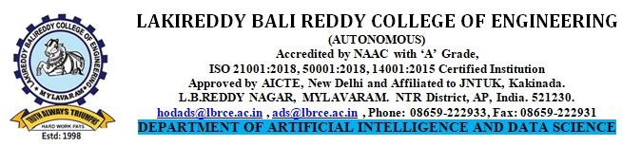
DESCRIPTIVE QUESTIONS

Name of Course Instructor: Mr. S. Siva Rama Krishna, Mr. S.V.V.D.Jagadeesh Reg: R23
Course Name & Code : DS & 23CS02 Cycle: 01
L-T-P Structure : 3-0-0 Credits: 3
Program/Sem/Sec : AI&DS/B.TECH/II A.Y.: 2023-24

Q.No | Question Description | Blooms Level | Course Outcome | UNIT
1 | Define Data structure? Elaborate different types of data structures with suitable examples. | L2 | CO1 | I
2 | Discuss different types of Asymptotic Notations with suitable examples. | L2 | CO1 | I
3 | Perform selection sort on the following list of elements 40,80, 35, 90,45,50,70,15,12,9,1,14. | L3 | CO1 | I
4 | After two passes of a sorting algorithm, the following array: 47, 3,66,32,56, 92, has been rearranged as follows: 3, 47, 66, 32, 56, 92 Which sorting algorithm is being used (selection, bubble or insertion) justify your answer. | L3 | CO1 | I
5 | Write recursive and non-recursive algorithm to search an element using binary search. | L2 | CO1 | I
6 | Let X = (x₁, x₂, … x_{n}), Y = (y₁, y₂, …y_{n}) be two lists with a sorted sequence of elements. Write a program to merge the two lists together as a single list Z with m + n elements. Implement the lists using singly linked list representations. | L3 | CO3 | II
7 | Write C functions to implement the following in CSLL i) Deletion at end ii) Insertion at begin | L3 | CO3 | II
8 | Write C functions to perform the following operations on double linked list? I. Insertion at Specified position II. Deletion at begin | L3 | CO3 | II
9 | Write C function to perform the following operations on single linked list:  - Count Number of Nodes  - Print in reverse order  - Find maximum element in the SLL  - Find minimum element in the SLL  - Sort elements in the SLL  - Remove duplicates from SLL  - Search particular key element in the SLL | L2 | CO3 | II
10 | Write a C function to perform addition of two polynomial expressions. | L3 | CO3 | II

Title | Course Instructor | Course Coordinator | Module Coordinator | Head of the Department
Name of the Faculty | Mr S Siva Rama Krishna | Dr. S.NAGARJUNA REDDY | Dr. Y.V.B REDDY | Dr. O Rama Devi
Name of the Faculty | Mr. S.V.V.D.Jagadeesh | Dr. S.NAGARJUNA REDDY | Dr. Y.V.B REDDY | Dr. O Rama Devi
Signature

